# Capstone Project: Relational Database

**Step 1: Choose a Leading Platform**

**Product Dissection for LinkedIn:**

.

This project includes information on top leading platform like LinkedIn, research its features, and meticulously craft a schema design that encapsulates the essence of its functionality. By focusing on key entities, attributes, and relationships , will gain invaluable insights into how data architecture drives the platform's effectiveness.

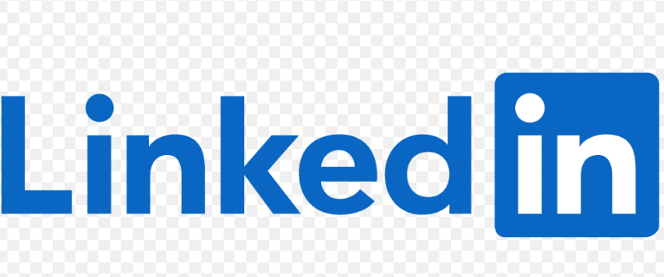

**Step 2: Research:**

### **Company Overview:**

LinkedIn is a professional social networking platform that was founded in December 2002 by **REID HOFFMAN** and launched in May 2003. The company's primary mission is to connect the world's professionals to make them more productive and successful. LinkedIn is widely regarded as the leading platform for professional networking and has transformed the way people connect, find jobs, and share industry insights.

LinkedIn is a social networking site focusing on professional networking and career advancement. We can use LinkedIn display resume, search for employment and build professional reputation by posting updates and communicating with others.

**Step 3 :Product Dissection and Real-World Problems solved by the platform**

#### **Problem 1: Information Overload**

**Real-World Challenge:**

In the professional world, individuals are bombarded with an overwhelming amount of information from various sources, including news, articles, updates, and job postings. This information overload can make it challenging to find relevant and valuable content and opportunities.

**LinkedIn's Solution:**

LinkedIn addresses information overload by offering features like customised feeds, content recommendations, followed hashtags, job recommendations, advanced search, and email digests. These tools help users find and prioritise the most relevant content and opportunities, streamlining their professional experiences.

#### **Problem 2: Disconnect in Digital Relationships**

**Real-World Challenge:**

In an increasingly digital world, maintaining genuine and meaningful professional relationships can be challenging.

Digital interactions often lack the depth and authenticity found in face-to-face connections, leading to a disconnect in digital relationships. Many professionals struggle to convey their personalities, emotions, and professional identities effectively in the digital realm.

**LinkedIn's Solution:**

LinkedIn addresses the challenge of disconnect in digital relationships by providing a platform that allows professionals to showcase their complete professional identity. Here's how:

**Rich User Profiles:** LinkedIn users can create detailed professional profiles that include their work history, skills, education, endorsements, and recommendations. These profiles serve as digital resumes and provide a holistic view of a professional's background and expertise.

**Media Sharing:** Users can enhance their profiles with media files, including documents, images, videos, and presentations. This feature allows professionals to showcase their work, portfolio, and projects, adding a personal touch to their profiles.

**Professional Insights:** The platform encourages users to share articles, posts, and updates about their industry, experiences, and interests. This content sharing enables users to express their thoughts, insights, and perspectives, fostering meaningful interactions.

**Recommendations and Endorsements:** Users can request recommendations and endorsements from colleagues and connections. These serve as endorsements of a user's skills and professionalism, adding credibility to their profiles.

**Connections and Networking:** LinkedIn's core feature is connecting with other professionals. Users can connect with colleagues, acquaintances, industry peers, and potential employers. These connections can lead to meaningful interactions and opportunities.

**Messaging and Conversations:** LinkedIn's messaging system allows users to have one-on-one conversations with their connections. It provides a platform for personalized communication, networking, and professional discussions.

By combining these features, LinkedIn enables professionals to bridge the gap in digital relationships. Users can express their professional identities, share their experiences, connect with like-minded professionals, and engage in meaningful conversations. This comprehensive approach empowers users to establish and nurture genuine professional relationships, addressing the challenge of disconnect in digital interactions.

#### **Problem 3: Finding a Niche for Creativity**

**Real-World Challenge:** Many individuals aspire to pursue creative endeavours, but finding a platform to showcase and monetize their talents can be daunting.

**LinkedIn's Solution:**

LinkedIn empowers creative professionals to exhibit their skills, expertise, and creative work through features like LinkedIn Articles, Project Showcases, and Professional Groups. This provides a platform for individuals to display their creativity, gain recognition, and connect with like-minded professionals. Creative individuals on LinkedIn can turn their passion into a professional niche, addressing the challenge of finding a platform for creativity and fostering personal and career growth. professional niche, addressing the challenge of finding a platform for creativity and fostering personal and career growth.

#### **Problem 4: Limited Personal Branding**

Real-World Challenge: Establishing a unique online identity can be challenging, as traditional text-based platforms often limit personal branding.

**LinkedIn's Solution:**

LinkedIn allows users to create comprehensive professional profiles that include a profile picture, professional headline, summary, featured content, and endorsements. This space enables users to showcase their skills, accomplishments, and personal brand in a professional context, addressing the challenge of limited personal branding on traditional platforms.

has become a leader in professional networking and personal branding, shaping the way professionals connect and build their careers online.

**Step 4: Case Study on the real world problems and approach to solving them**

**"Networking Revitalized: A LinkedIn Success Story"**

**Introduction:**

LinkedIn, the world's leading professional networking platform, has transformed the way individuals build and cultivate their professional connections. This case study explores the detailed story of Mark, a mid-career professional facing networking challenges, and how LinkedIn's unique features played a crucial role in overcoming these difficulties.

**User Background:**

Mark, a 38-year-old marketing strategist, found himself at a crossroads in his career. Despite possessing valuable skills and experience, he struggled to expand his professional network, explore new opportunities, and stay updated with industry trends. Mark's limited network hindered his job search and career growth.

**User Difficulties:**

**Limited Professional Network:**

Mark's existing professional network was relatively small, consisting mainly of colleagues and acquaintances. This limited network hindered his ability to access diverse perspectives, job opportunities, and industry insights.

**Ineffective Job Search:**

Mark found traditional job search methods insufficient and time-consuming. He faced challenges in discovering relevant job openings and showcasing his skills to potential employers.

**Lack of Industry Insights:**

Keeping up with the rapidly evolving marketing landscape was a struggle for Mark. He felt disconnected from industry trends and missed out on valuable insights that could enhance his professional knowledge.

**LinkedIn's Unique Features:**

Professional Networking Opportunities:

LinkedIn's core feature, the ability to connect with professionals globally, allowed Mark to expand his network strategically. He started connecting with colleagues, industry leaders, and professionals in related fields, fostering a diverse and expansive network.

**Job Search and Application:**

LinkedIn’s job search and application features empowered Mark to explore relevant job openings. The platform’s algorithm recommended positions based on his skills and experience, streamlining the job search process.

**Content Sharing and Industry Engagement:**

Mark leveraged LinkedIn's content-sharing capabilities to share his insights, industry news, and professional achievements. This increased his visibility within his network and positioned him as an industry thought leader.

**Recommendations and Endorsements:**

The platform's recommendation and endorsement features allowed Mark to showcase his skills and receive recognition from colleagues and peers. Positive endorsements strengthened his professional credibility.

**Outcome:**

Mark’s proactive use of LinkedIn resulted in several positive outcomes:

**Expanded Professional Network:**

Mark's connections grew exponentially, providing him with a diverse network of professionals who shared valuable insights, job opportunities, and collaborative prospects.

**Successful Job Transition:**

LinkedIn's job search and application features facilitated Mark's transition to a new and challenging role that aligned with his career goals and aspirations.

**Enhanced Industry Knowledge:**

Engaging with industry-related content and thought leaders on LinkedIn enabled Mark to stay abreast of the latest trends and developments in the marketing field, enhancing his professional knowledge.

**Conclusion:**

Mark's success story on LinkedIn underscores the platform's unique features as powerful tools for overcoming professional networking challenges. By strategically leveraging LinkedIn's capabilities, Mark transformed his career trajectory, expanded his professional network, and gained access to a wealth of opportunities and industry insights. This case study illustrates how LinkedIn's user-centric features can empower individuals to navigate the complexities of the professional landscape and achieve their career goals.

**Step 5: Schema Design Based on Top Features**

### **Top Features of LinkedIn:**

LinkedIn is a business-oriented social media platform with over 740 million members. Some of its top features include:

* **Showcase page**: A key feature for businesses with multiple target audiences
* **Name pronunciation**: Users can record an audio clip of how to pronounce their name and add it to their profile
* **Save posts**: Users can save job searches, posts, and LinkedIn learning programs
* **Private messaging**: Users can access private messaging and groups
* **Alumni search**: Users can search for alumni
* **Keywords**: Users can use keywords
* **Activity**: Sharing relevant content with your network
* **Hashtag**: LinkedIn hashtags are **terms with a "#" symbol before keywords**. They are used in posts, comments, and add descriptions to increase reach. Hashtags can also help people connect with like-minded people on the platform.

### **Schema Description:**

The schema for LinkedIn involves multiple entities that represent different aspects of the platform. These entities include Profile, Posts, Comments, Likes, Followers, Hashtags, and more. Each entity has specific attributes that describe its properties and relationships with other entities.

**Profile Entity:**

Users are central to LinkedIn. The user entity contains information about each professional user:

* UserID (Primary Key): A unique identifier for each user.
* User_name: The first name of the user.
* Full_Name: The Full name of the user.
* Headline: A professional headline summarising the user's expertise or current role.
* Email: The user's email address for professional communication.
* Summary: A brief professional summary or bio.
* Skills: A list of skills associated with the user's professional profile.
* Connection_Count: The count of professional connections.
* Profile_Date: The date when the user joined LinkedIn.

**Post Entity:**

Posts allow users to share professional updates and insights:

* PostID (Primary Key): A unique identifier for each post.
* UserID (Foreign Key referencing User Entity): The user who created the post.
* Content: The text or media content shared in the post.
* Image_URL: The URL of any image or media attached to the post.
* Post_Date: The date when the post was created.

**Comment Entity:**

Comments enable users to engage in discussions on posts:

* CommentID (Primary Key): A unique identifier for each comment.
* PostID (Foreign Key referencing Post Entity): The post being commented on.
* UserID (Foreign Key referencing User Entity): The user who posted the comment.
* Text: The text content of the comment.
* Comment_Date: The date when the comment was posted.

**Like Entity:**

Likes represent user appreciation for posts:

* LikeID (Primary Key): A unique identifier for each like.
* PostID (Foreign Key referencing Post Entity): The post being liked.
* UserID (Foreign Key referencing User Entity): The user who liked the post.
* Like_Date: The date when the like was registered.

**Follower Entity:**

Followers establish professional connections between users:

* FollowerID (Primary Key): A unique identifier for each follower relationship.
* FollowingUserID (Foreign Key referencing User Entity): The user who is being followed.
* FollowerUserID (Foreign Key referencing User Entity): The user who is following.
* Follow_Date: The date when the following relationship was initiated.

**Hashtag Entity:**

Hashtags categorise and group content based on professional topics:

* HashtagID (Primary Key): A unique identifier for each hashtag.
* Tag: The actual text of the hashtag.

**PostHashtag Entity:**

Associates posts with hashtags:

* PostHashtagID (Primary Key): A unique identifier for each association.
* PostID (Foreign Key referencing Post Entity): The post associated with the hashtag.
* HashtagID (Foreign Key referencing Hashtag Entity): The hashtag associated with the post.

**Step 6: Relation Behind the Design**

**Relationships are:**

**1.Users create Posts:**

* Each user on LinkedIn can create multiple posts.
* Each post is created by one user.

**2.Users comment on Posts:**

* Users on LinkedIn can comment on multiple posts.
* Each post can have multiple comments.
* Each comment is made by one user.

**3.Users like Posts:**

* LinkedIn users can like multiple posts.
* Each post can have multiple likes.
* Each like is registered by one user.

**4.Users connect with other Users:**

LinkedIn users can connect with multiple other users.

* Each user can be connected with multiple users.
* The connection relationship is reciprocal – if User A connects with User B, it implies that User B is also connected with User A.

**5.Users follow Company Pages:**

* LinkedIn users can follow multiple company pages.
* Each company page can be followed by multiple users.

**6.Users endorse Skills on Profiles:**

* LinkedIn users can endorse multiple skills on the profiles of other users.
* Each skill on a user's profile can be endorsed by multiple users.

**7.Users join and participate in Groups:**

* LinkedIn users can join multiple groups.
* Each group can have multiple members.
* Users can participate in discussions within these groups.

**8.Users send and receive Messages:**

* LinkedIn users can send messages to multiple other users.
* Each message is sent by one user and received by another user.

**9.Users post and share Articles:**

* LinkedIn users can post and share multiple articles.
* Each article is posted by one user.

**10.Users recommend and get Recommendations:**

* LinkedIn users can recommend multiple skills on the profiles of other users.
* Each skill on a user's profile can be recommended by multiple users.

### **Step 7: Create an ER Diagram**

### **ER Diagram:**

Let's construct an ER diagram that vividly portrays the relationships and attributes of the entities within the LinkedIn schema. This ER diagram will serve as a visual representation, shedding light on the pivotal components of the LinkedIn data model. By employing this diagram, you'll gain a clearer grasp of the intricate interactions and connections that define the platform's dynamics.

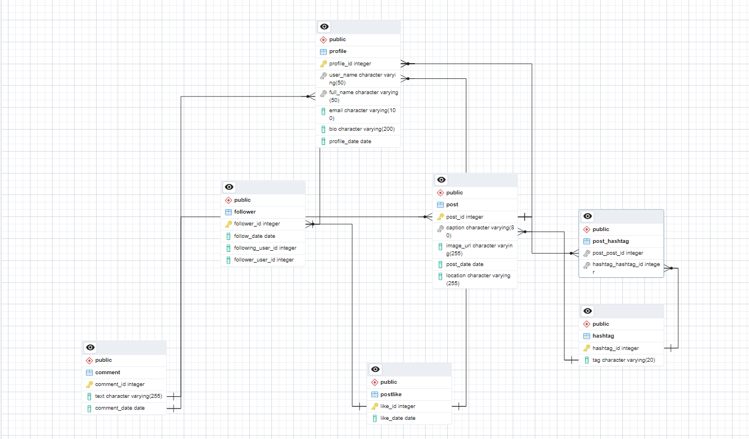

**Step 8: Findings**

In this case study, we delved into the design of LinkedIn schema and Entity-Relationship diagram. LinkedIn has revolutionised the way people share and engage with visual content, fostering connections and creative expression. The platform's intricate data model, consisting of entities like profiles, posts, comments, likes, followers, hashtags, and associations, forms the foundation for its seamless functionality. By understanding this schema, we gain insight into how LinkedIn effectively manages the complexities of profiles interactions and content sharing, contributing to its widespread popularity and continued growth in the world of social media.